Test 1. Run program: 13:05

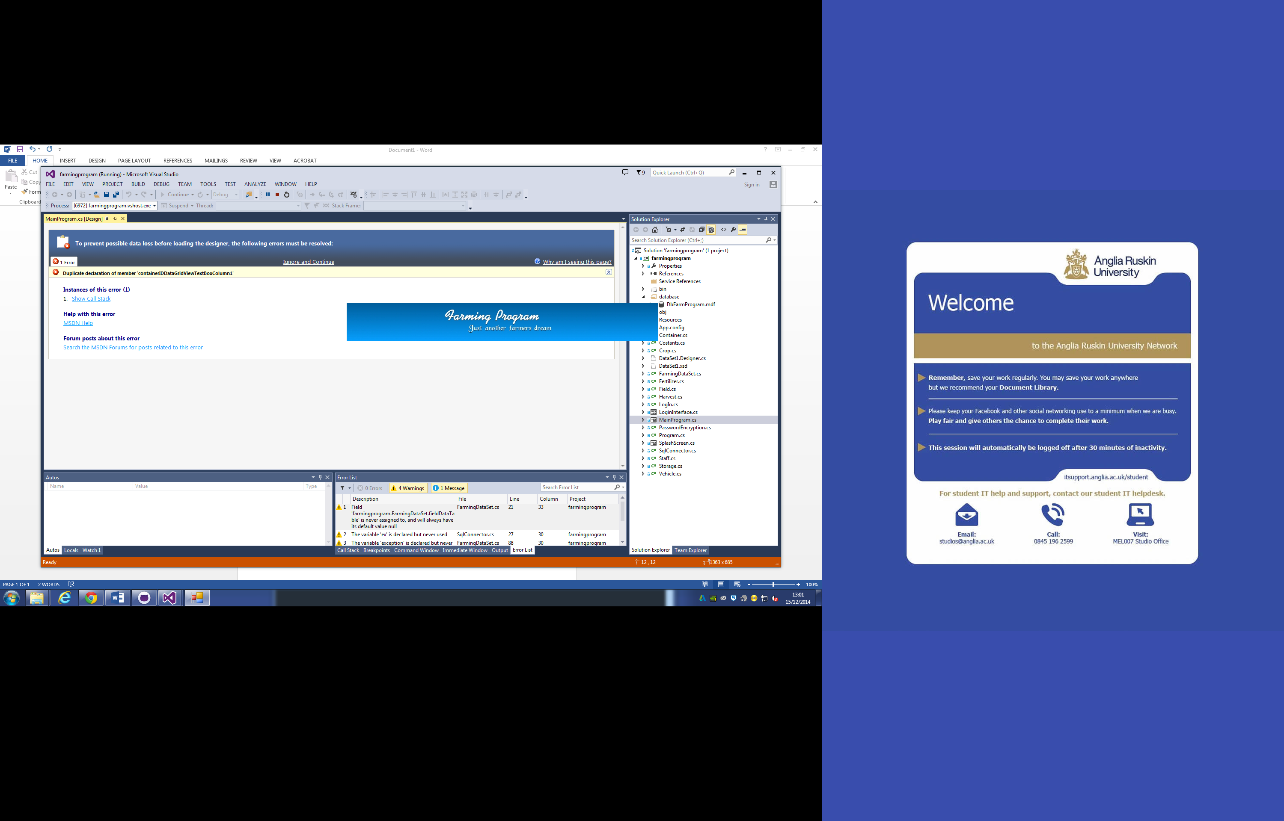

Test 2. Enter user name and password to access database : 13:06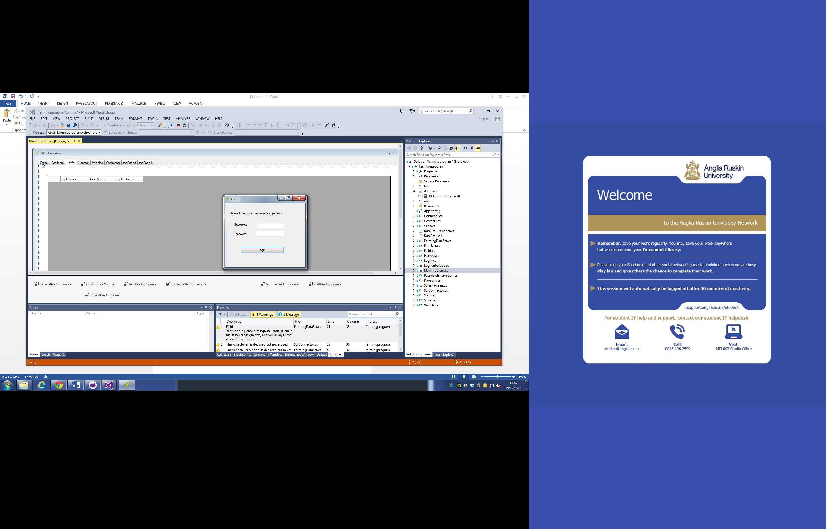

Test 3. Username and password entered : 13:10

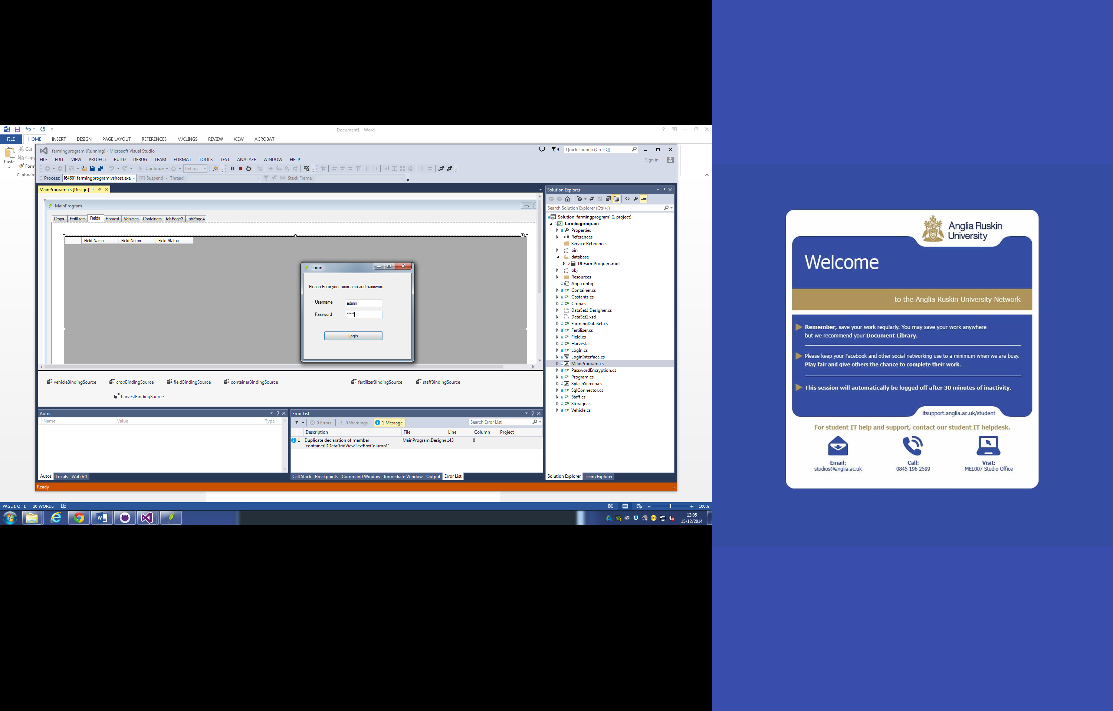

Test 4. Tables from classes presented 13:15

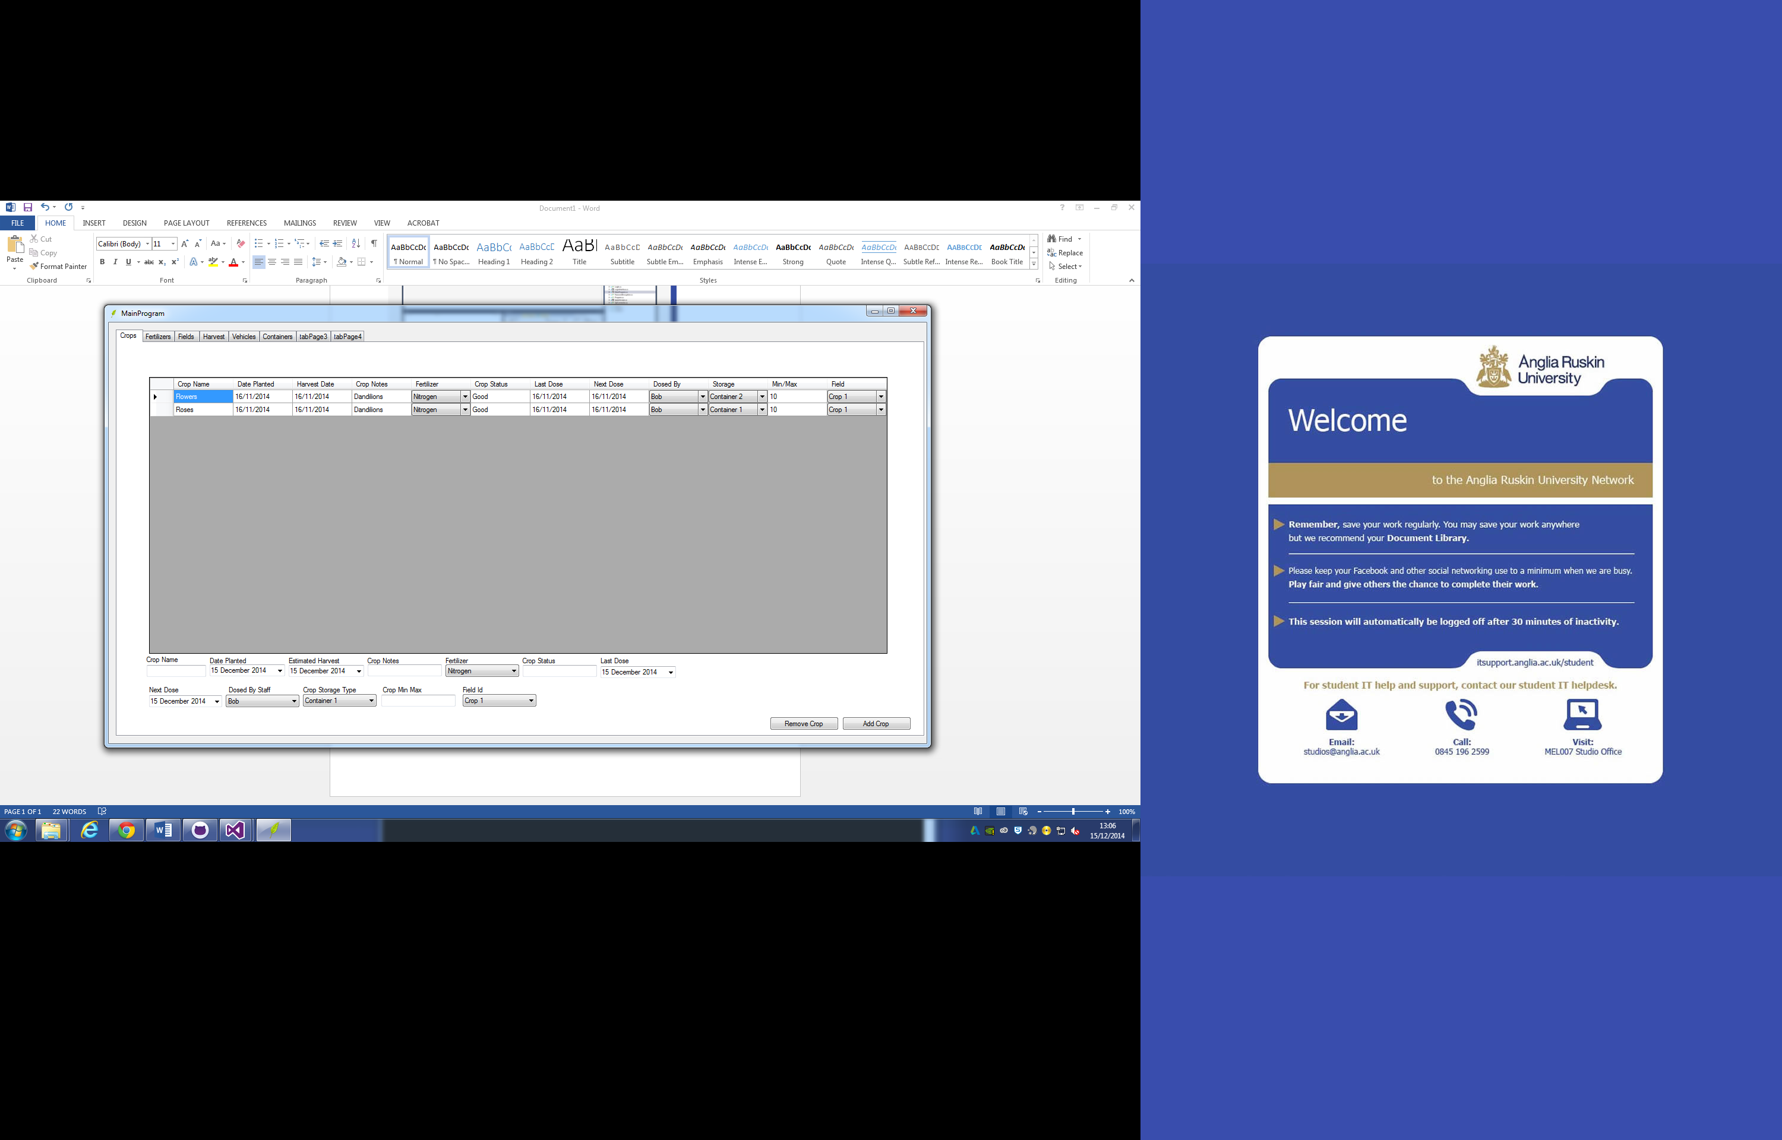

Test 5. Add a field in fertiliser 13:16

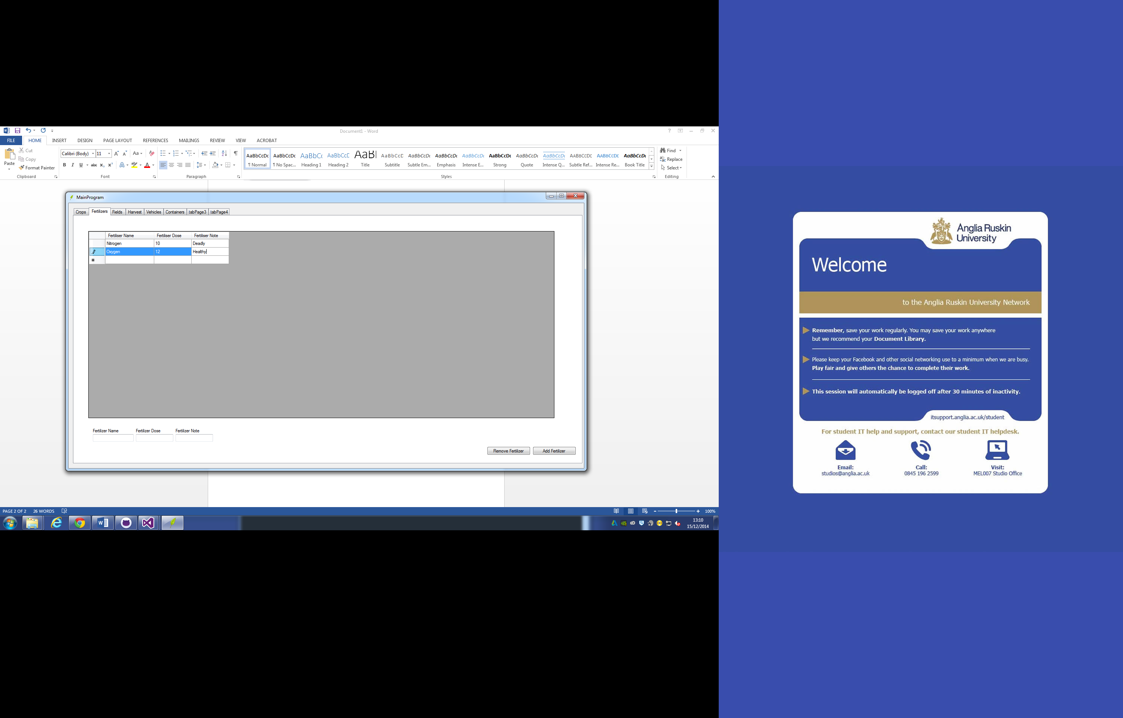

Test 6. Couldn’t edit while program was open 13:20

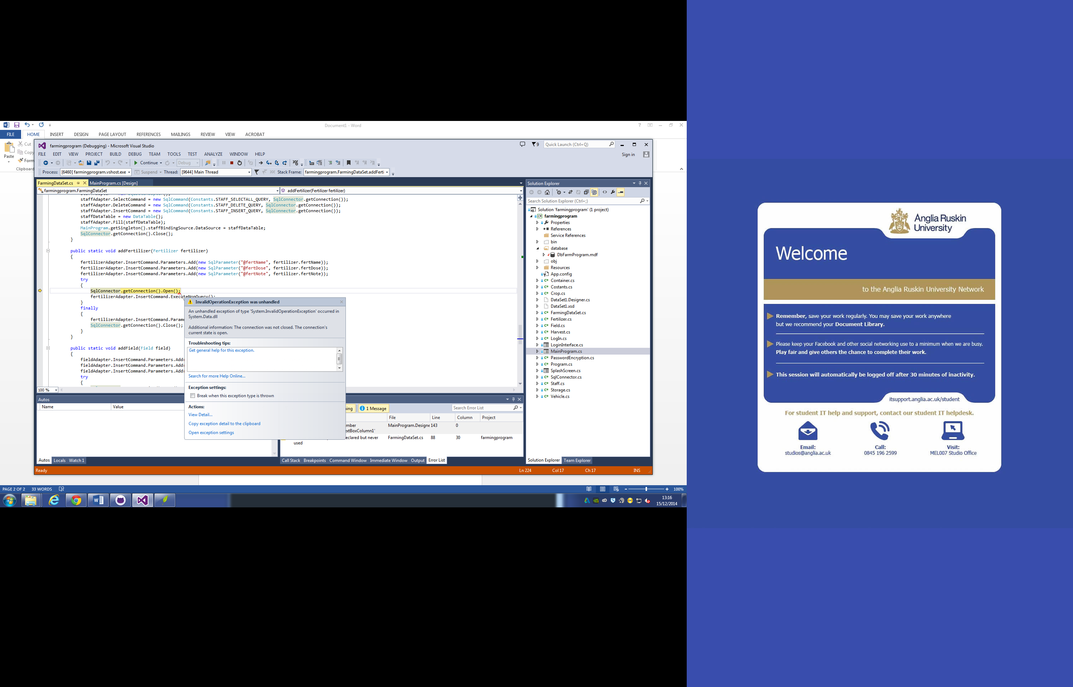

Test 7. Harvest not displaying because initialised harvest set not completed 13:40

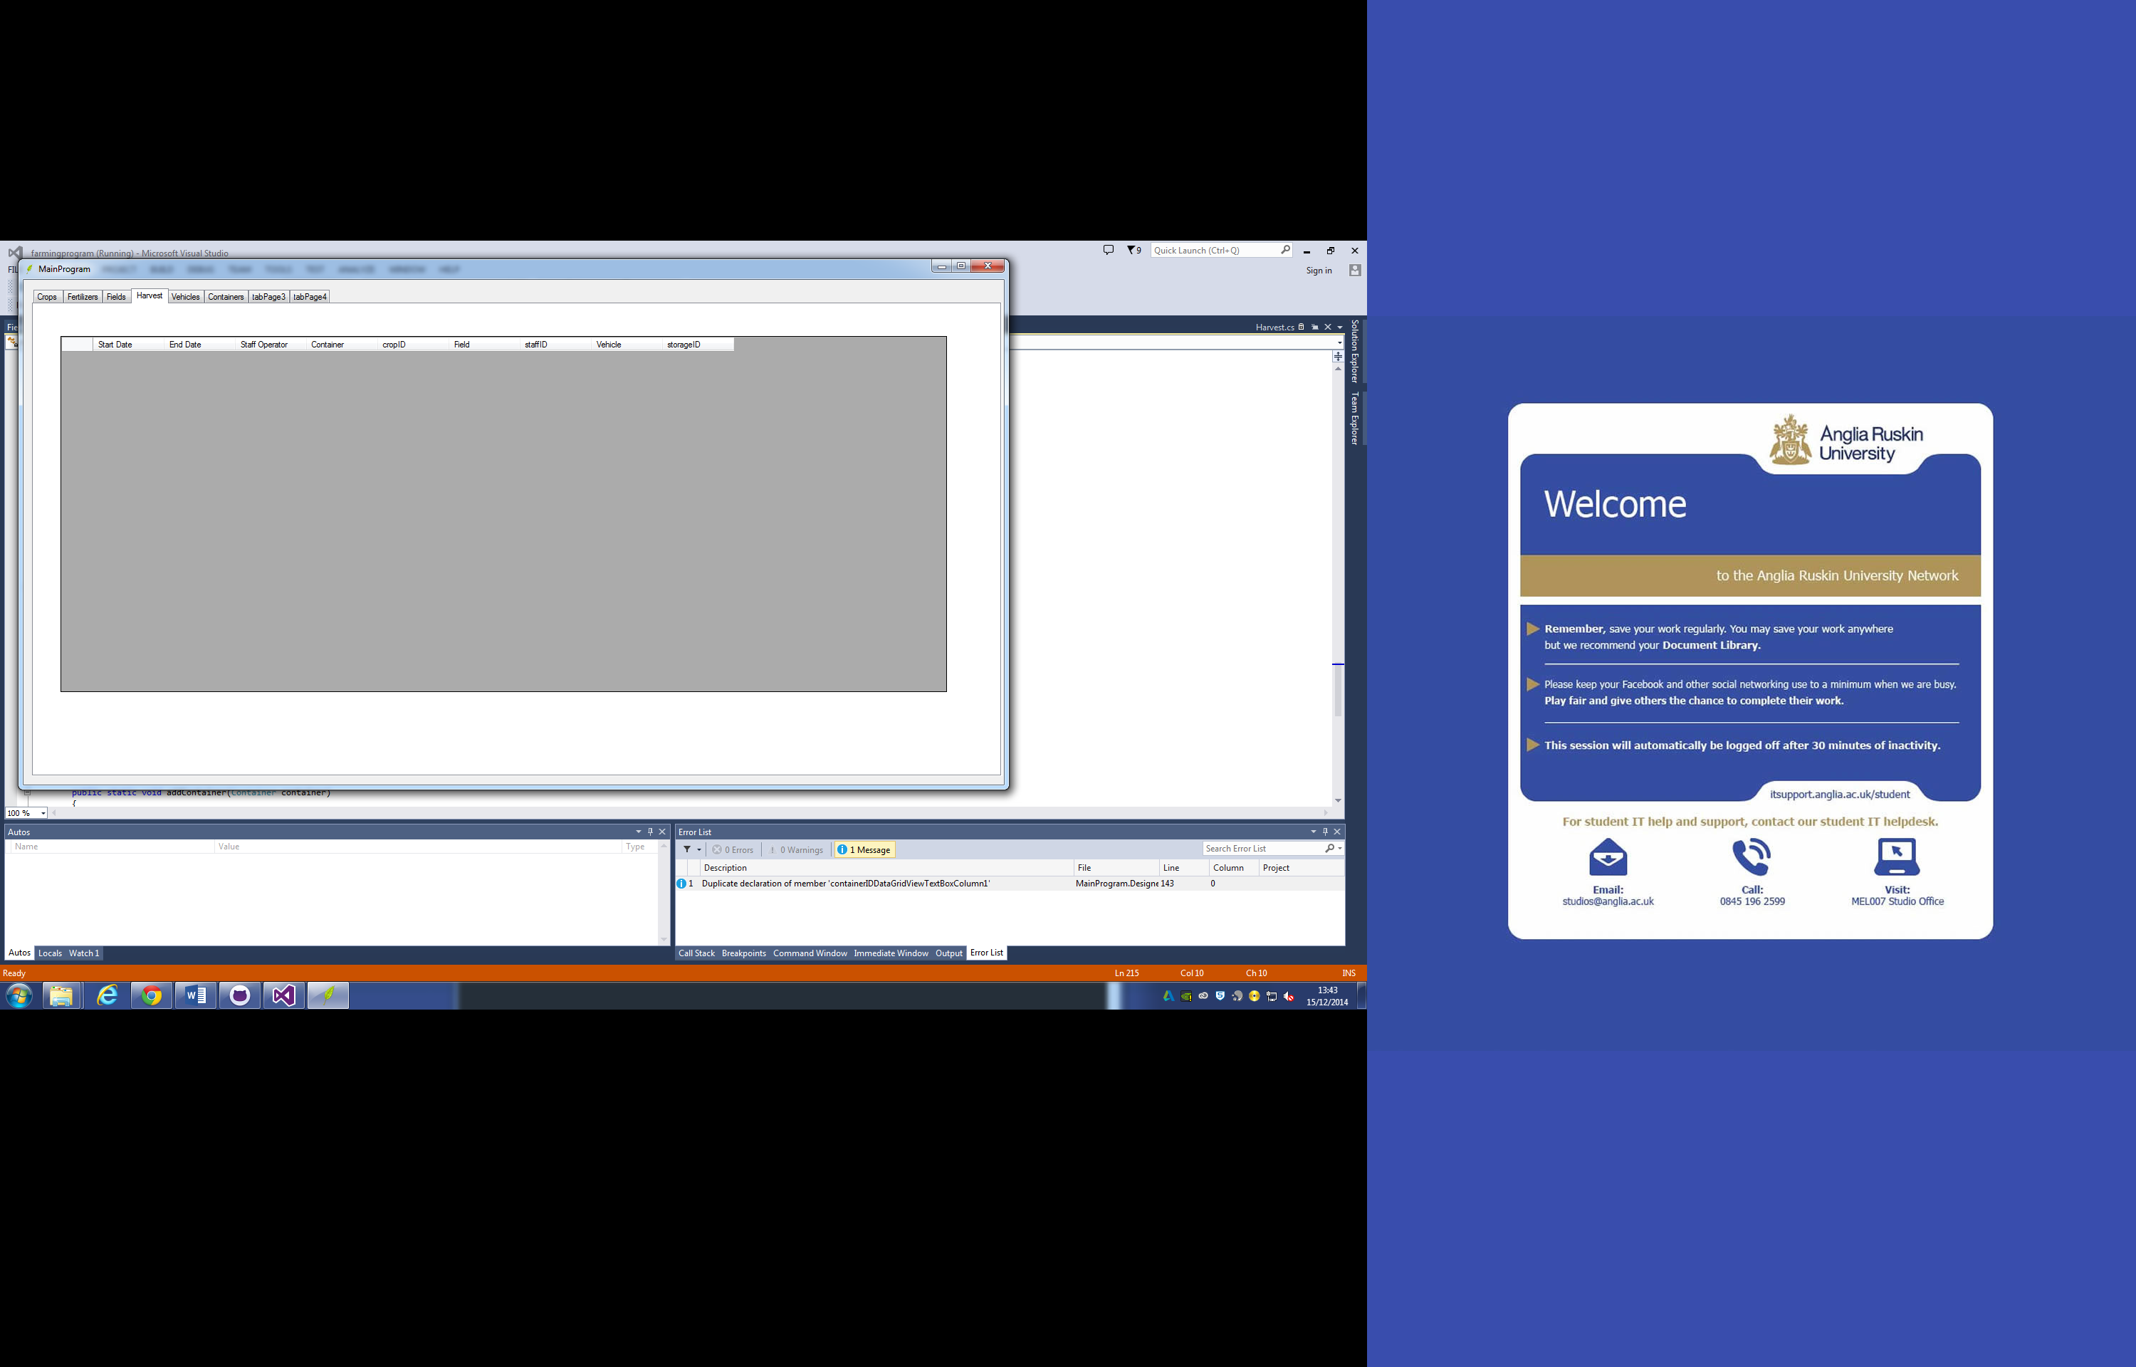

Test 8. Not allowing a non int value to be entered 13:45

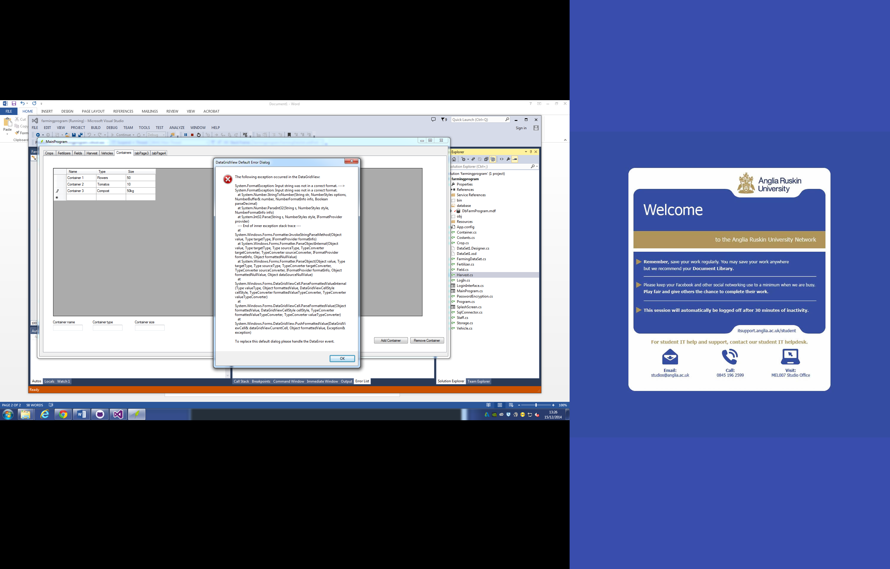

Test 9. No fields entered because of initialize set error. 13:47

Test 10. Cannot enter a int over the max value 13:48